SECTION 096466 --- WOOD GYMNASIUM FLOORING

PART 1-GENERAL

1.1 DESCRIPTION

A. This document specifies a wood strip athletic floor system consisting, in general, of wood subflooring, maple flooring, vapor retarder, vertical restraints (system specific), sanding, sealers, finishes, game lines, and wall base.
B. The concrete contractor shall provide a concrete slab, smooth troweled and level to a tolerance of 1/8”
(3mm) in a 10’0” (3m) radius, subject to the approval of the wood flooring contractor. LABOR AND MATERIALS NECESSARY TO PUT THE CONCRETE SLAB IN ACCEPTABLE CONDITION (HIGH AREAS GROUND DOWN AND LOW AREAS FILLED WITH APPROVED LEVELING COMPOUNDS) SHALL BE THE RESPONSIBILITY OF THE CONCRETE CONTRACTOR.
1. Concrete slab depression to use for 7/16” (11mm) padding shall be:
a. 1 7/8” (55mm) for 25/32” (20mm) thick flooring
2. Concrete subfloors shall have an adequate vapor retarder beneath and at the perimeter of the slab.
3. No pea gravel, river gravel or slag aggregate shall be allowed in the concrete. The concrete strength range at the time of wood flooring installation shall be between 3,000 PSI and 3,500 PSI.

1.2 QUALITY ASSURANCE

A. Supplier Qualifications
1. Supplier of wood flooring shall be Horner Flooring Company.
2. Basis of design shall be Horner’s “Zenith” sports floor system as provided by Horner Flooring, www.hornerflooring.com. (800-380-0119).
3. Materials other than those listed must be approved 10 days prior to bid date by written addendum.
Materials from non-approved manufacturers will not be accepted. B. Installer Qualifications
1. The flooring contractor shall be a Horner Accredited Installation Company with MFMA Accredited
Installer(s) on-site for the duration of the wood floor installation; or, a contractor approved by
Horner Flooring.
C. Flooring shall be stored on the premises before installation commences as required for acclimation.
Final determination as to acclimation will be made by the flooring contractor. D. System meets necessary DIN/EN requirements.

1.3 WORKING CONDITIONS

A. The floor system shall not be delivered or installed until the concrete slab is properly cured and all masonry, plastering, tile work and overhead mechanical trades are completed and building is permanently enclosed and weathertight.
B. Permanent heat, light and ventilation shall be installed and operative during and after installation, maintaining a temperature range of 55o F (13 o C) to 75o F (24 o C) and a relative humidity range that changes no more than 15% from low to high humidity levels.
C. HVAC System shall be operating in balance at levels and conditions consistent with those during permanent occupancy.

1.4 WARRANTY

A. Horner Flooring Company hereby warrants the flooring materials to be free from manufacturing defects for a period of one year from the date of substantial completion. This warranty is expressly limited to the flooring materials supplied by Horner. This warranty is in lieu of all other warranties, expressed or implied including but not limited to any warranty of merchantability or fitness for a particular purpose, and of any other obligations on the part of Horner. This warranty does not cover floor damage caused by conditions beyond our control, such as fire, wind, floor surface chemical action, faulty maintenance, improper ventilation, faulty construction of building, Act of God, ordinary wear and tear, excess moisture and excess dryness, separation of concrete slab, settlement of walls, failure of floor if not installed properly, when installed over poured urethane if poured urethane returns to its liquid state, if poured urethane releases from concrete slab or failure of floor if installed over polyvinyl chloride synthetic flooring. In the event of breach of any warranty, the liability of Horner shall be limited to repairing or

replacing material and system components supplied by Horner and proven to be defective in manufacture, and shall not include any other damages, either direct or consequential.
B. Extended warranties are based on maintenance and yearly/annual cleaning and recoating agreements
with certified contractors.

PART 2-PRODUCTS

2.1 MATERIAL

A. Flooring shall be Horner 25/32" (20mm) or 33/32" (26mm) thick x 2 ¼” (57mm) or 1 ½” (38mm) wide First, Second and Better, Third and Better or Third Grade, random length continuous tongue and groove and end-matched MFMA Northern Hard Maple, grade marked and stamped as manufactured by Horner Flooring Company.
OPTION: Horner Long Life™ flooring if so specified. B. Vapor retarder shall be 6 mil polyethylene.
C. Pads shall be 7/16” (11mm) pads provided by the Horner Flooring Company.
D. Subfloor shall be 2 layers 15/32” (16mm x 1219 mm x 2438 mm) rated sheathing, exposure 1, plywood customized with CNC modified pad pocket inserts.
E. Fasteners
1. Flooring fasteners shall be 2 ” (51mm) barbed cleat or 15 gauge (1.8mm) coated staples.
2. Subflooring fasteners shall be 1” (25mm) cleats or staples.
F. Wall base shall be 3” x 4” (76mm x 102mm) Vent Cove heavy duty molded, vented base with premolded outside corners as supplied by Horner Flooring Company. Specify color: black or brown.
G. Finish material shall be specified from the latest listing provided by the MFMA, and shall be applied according to finish manufacturer’s instructions.
H. Gameline paint shall be compatible with finish.

PART 3-EXECUTION

3.1 INSPECTION

A. Inspect concrete slab for proper tolerance and dryness and report any discrepancies to the general contractor for correction.
B. The concrete slab shall be cleaned of all debris so flooring contractor will have adequate access to work surface.
C. All overhead work and wet trades shall be complete in floor work area.
G. Solid blocking shall be attached to areas under bleachers in the closed position. Solid blocking shall match the thickness of system pad. Solid blocking shall be a minimum of 4” wide and 12” O.C.
H. Expansion Provisions-Size joints between maple flooring strips to allow for intermediate expansion in
accordance with expected humidity changes and conditions in the space.

3.2 INSTALLATION- Installation per Horner’s Installer manual
3.3 FLOOR SANDING

A. Machine sand with coarse, medium and fine paper to a smooth, even and uniform surface. B. Remove sanding dust from entire surface by tack of vacuum.
C. Refer to MFMA sanding and finishing guide for procedures.

3.4 FINISHING

A. Inspect entire area of floor to insure that surface is acceptable for finishing, completely free from sanding dust and perfectly clean.
B. Apply seal and finish per finish manufacturer’s instructions.
C. Buff and clean floor between each coat or as necessary.
D. Paint game lines as shown on drawings, between seal coats. E. Game line paint shall be compatible with finish.

3.5 BASE INSTALLATION

A. Install Vent Cove base, mitering inside corners and anchoring to walls with base cement or screws and anchors.

3.6 MAINTENANCE

A. Upon completion of floor installation, the owner, attendants or individuals in charge and responsible for the upkeep of the building are to see that the care and maintenance instructions outlined within the provided Horner Care and Maintenance Manual are followed. Horner flooring and certified dealers may offer extended warranty and maintenance agreements. It is recommended that any extended agreements include maintenance and recoats by the original installing contractor or related/recommended parties. (See maintenance/cleaning and recoating information on Horner Flooring website).

END OF SECTION

25/32" OR 33/32" THICK BY
1-1/2" OR 2-1/4" WIDE
HORNER HARD MAPLE FLOORING

3"X4" VENT COVE BASE

1-1/2" EXPANSION VOID

2"FASTENER

2 LAYERS 15/32" THICK APA-RATED SHEATHING PLYWOOD, EXPOSURE 1
OR 7/16" OSB

ELECTRICAL BOX
(MAY VARY WITH LOCAL FIRE CODES)

ALUMINUM THRESHOLD
I I
1-1/2" EXPANSION VOID
.·..

CNC MODIFIED
PAD POCKET INSERT

6 MIL. POLY
VAPOR RETARDER

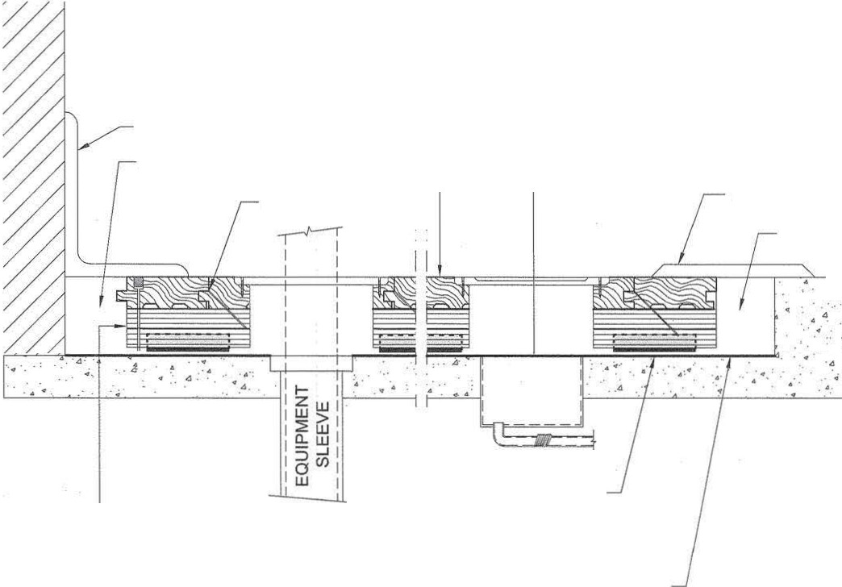ZENITH SYSTEM
HORNER FLOORING COMPANY DOLLAR BAY, Ml
11-01-09

CLOSE UP
CNC MODIFIED
PAD POCKET INSERT

3"x4" VINYL VENT
1----- - COVE WALL BASE

!!2! 6:1_J
1/8" OF THE PAD EXTENDS OUTSIDE
THE PLYWOOD

ALUMINUM THRESHOLD ---------,

25/32" OR 33/32" THICK BY
1-1/2" OR 2-/1/4" WIDE
HORNER HARD MAPLE FLOORING

: '

'
2 LAYERS 15/32" THICK APA-RATED I
L- - -SHEATHING PLYWOOD, EXPOSURE 1
OR 7/16"

6 MIL POLYETHYLENE FILM VAPOR RETARDER, LAPPED 4" AND TAPED AT SEAMS

L_ 1-1/2" EXPANSION VOID AT PERIMETER OF FLOOR
7/16" HORNER ECO PADS

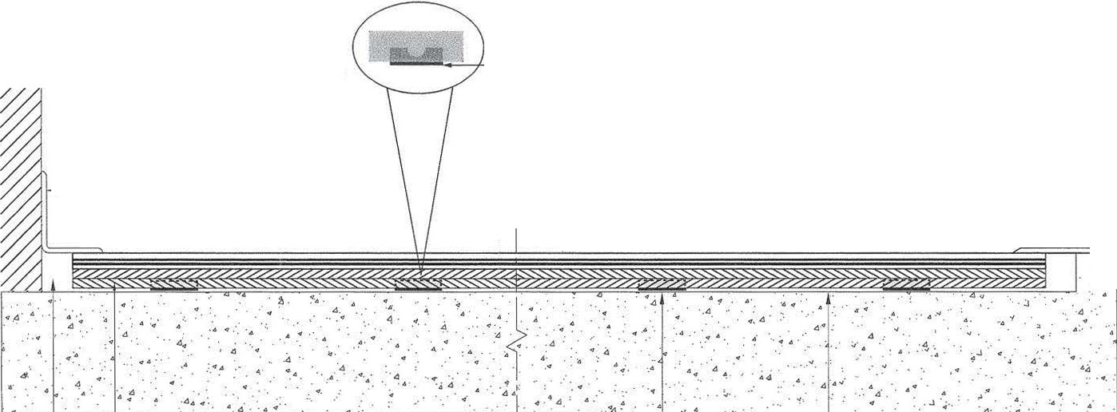

ZENITH SYSTEM
FLOORING
 | 25/32" (20mm) | 33/32" (26mm)
7/16" PAD (11mm) | 1 7/8" (47.6mm) | 2-3/8" (60mm)

SIDE VIEW

HORNER FLOORING COMPANY DOLLAR BAY, Ml
11-01-09

